**LEBANESE AMERICAN UNIVERSITY**

**USAID – HIGHER EDUCATION SCHOLARSHIP PROGRAM**

**HES - Volunteering Program Verification Form**

This form is to be used to document volunteering hours. If a student volunteers for multiple organizations, a separate form must be used for each organization. **This form must be turned in by the 28th of each month, the latest.**

I certify that the scholar Rabih Fadi Khalil completed a total of 4 hours of service at Life Sculptor.

The hours were completed hours as per the below:

Hours # 1 (date) _02/09 - 06/09_ (initials of supervisor) __A.K.___

Hours # 1 (date) _09/09 – 13/09_ (initials of supervisor) __A.K.___

Hours # 1 date) _16/09 – 20/09 (initials of supervisor) __A.K.___

Hours # 1 date) _23/09 – 27/09 (initials of supervisor) __A.K.___

Brief description of the activities the scholar performed or participated in:

I performed a research on Reducing Single_Use Plastics  
Community Engagement  
Minimalism and Decluttering   
Sustainable Transportation

Written feedback about the scholar’s performance:

Rabih Khalil conducted research on key sustainability topics, including reducing single-use plastics, community engagement, minimalism and decluttering, and sustainable transportation. His work highlights important strategies for promoting environmental awareness and encouraging sustainable practices within communities.

Please rate the overall performance of the scholar at your organization:

|  |  |  |  |
| --- | --- | --- | --- |
|  | Mastery (5) | Proficient (3) | Emerging (1) |
| **Problem solver** | X |  |  |
| **Engaged & Committed** | X |  |  |
| **Open-minded & multicultural** | X |  |  |

Signature

& stamp

__________________________

_

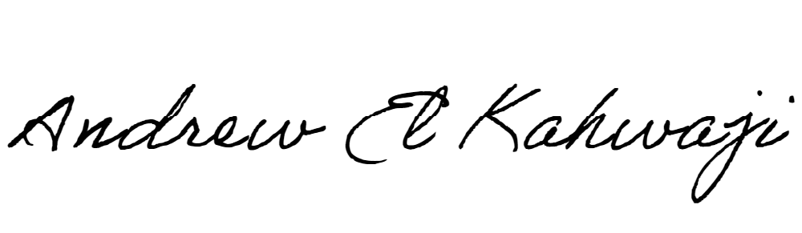

Printed Name _Andrew El Kahwaji_

Date __25/09/2024___

Email __andrew.lifesculptor.coo@gmail.com __

Phone __+961 71 914 378__

**LEBANESE AMERICAN UNIVERSITY**

**USAID – HIGHER EDUCATION SCHOLARSHIP PROGRAM**

